SCHOOLOFCOMPUTER SCIENCE AND ARTIFICIAL INTELLIGENCE |  |  |  |  | DEPARTMENTOFCOMPUTER SCIENCE ENGINEERING
ProgramName:M.Tech/MCA/MSC |  |  |  | AssignmentType: Lab |  |  | AcademicYear:2025-2026
CourseCoordinatorName |  |  |  | Venkataramana Veeramsetty
CourseCode |  |  |  | CourseTitle |  | AI Assisted Problem Solving Using Python
Year/Sem |  |  | I/I | Regulation |  | R25
DateandDay  of Assignment |  |  |  | Time(s)
Duration |  |  | 2 Hours | Applicableto  Batches
AssignmentNumber:16.3(Presentassignmentnumber)/24(Totalnumberofassignments)
 | Q.No. | Question |  |  |  |  |  | ExpectedTime  to complete
 | 1 | Lab 16 – Database Design and Queries: Schema Design and SQL Generation  Lab Objectives  - To practice basic SQL query generation with AI assistance.  - To analyze AI-suggested queries for correctness and efficiency.  - To understand how AI can help in documenting and improving database logic.  Learning Outcomes  After completing this lab, students will be able to:  - Use AI tools to design a simple ER diagram / schema for a given scenario.  - Generate CREATE TABLE statements using AI.  - Write and refine basic SQL queries (SELECT, INSERT, UPDATE, DELETE).  - Validate correctness and efficiency of AI-generated SQL.  - Compare AI-generated vs manually written queries.  Task Description #1 – Schema Generation  Task: Ask AI to design a schema for a Library Management System (Tables: Books, Members, Loans).  Promt:  Schema Generation Prompt given to AI: “Design a complete and correct database schema for a Library Management System with three tables: Members, Books, and Loans. Include proper primary keys, foreign keys, suitable data types, UNIQUE constraint for email, BOOLEAN for book availability, and DATE fields. Generate clean CREATE TABLE statements in MySQL syntax.”  SQL Code  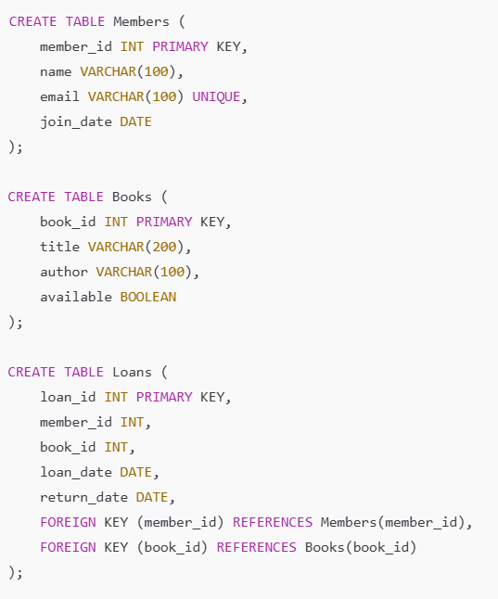  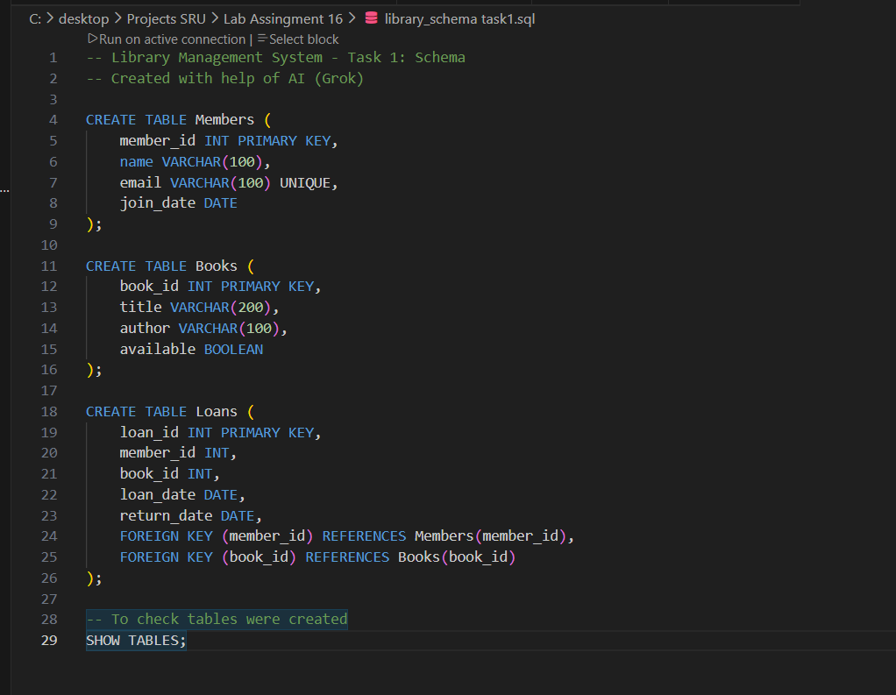  Schema Generation (Completed)  What we have done:  - Used AI to design a complete database schema for a Library Management System.  - Created three tables:  - Members (to store library members’ details)  - Books (to store book information)  - Loans (to track which member borrowed which book)  - Added proper primary keys, foreign keys, unique constraints, and suitable data types.  - Ensured relationships between tables using FOREIGN KEY (Loans links to Members and Books).  - Executed the schema successfully on OneCompiler MySQL online editor.  - Verified table creation using SHOW TABLES; command.  - Saved the final SQL code in VS Code as library_schema.sql for future use and GitHub submission.  - Prepared screenshot proof of successful execution.  Result: A complete, correct, and professional database schema is ready for inserting data.  Task Description #2 – Error Insert Data  Task: Ask AI to generate INSERT INTO queries for the schema above (3 sample records per table).  Prompt : Insert Sample Data Prompt given to AI: “Generate 9 INSERT statements (3 records for Members, 3 for Books, 3 for Loans) using the schema we just created. Use realistic names, emails, book titles, authors, TRUE/FALSE for available, and NULL for books not yet returned.  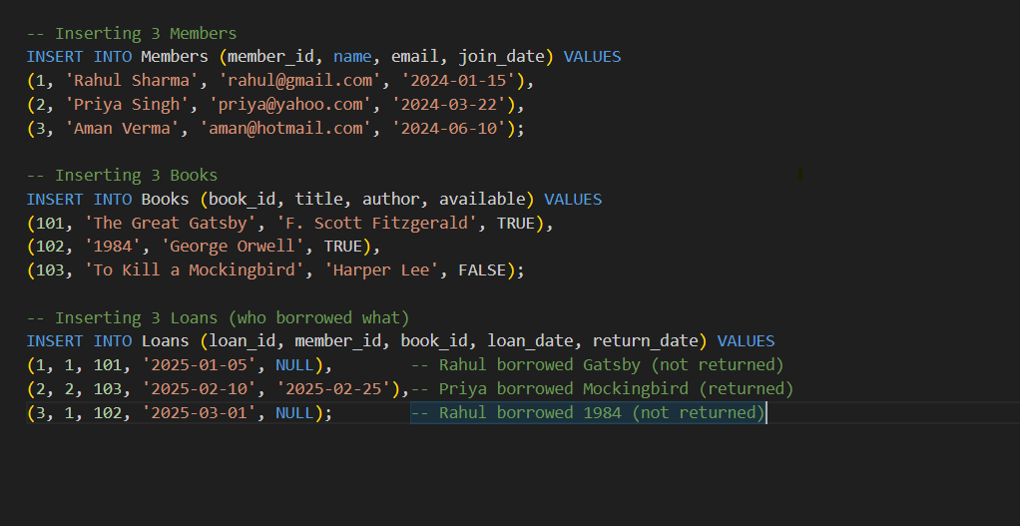  Insert Sample Data (Completed)  What we have done:  - Asked AI to generate 9 INSERT statements (3 records for Members, 3 for Books, 3 for Loans).  - Successfully executed all INSERT statements on OneCompiler MySQL without any error.  - Added realistic sample data including names, emails, book titles, authors, availability status, loan dates, and return dates (using NULL for books not yet returned).  - Verified all 9 records were correctly inserted by running SELECT queries on each table.  - Took screenshot of the insertion process and results as proof.  - Saved everything safely in VS Code for future use and submission.  Result: Database now contains complete sample data and is ready for next tasks.  Task Description #3 – Basic Queries  Task: Use AI to generate a query to list all books borrowed by a specific member  Prompt: Basic Query Prompt given to AI: “Write a clean SQL query using JOINs to list all books borrowed by a specific member (Rahul Sharma – member_id = 1). Show Member Name, Book Title, Author, Loan Date, and Return Date in a readable format.”  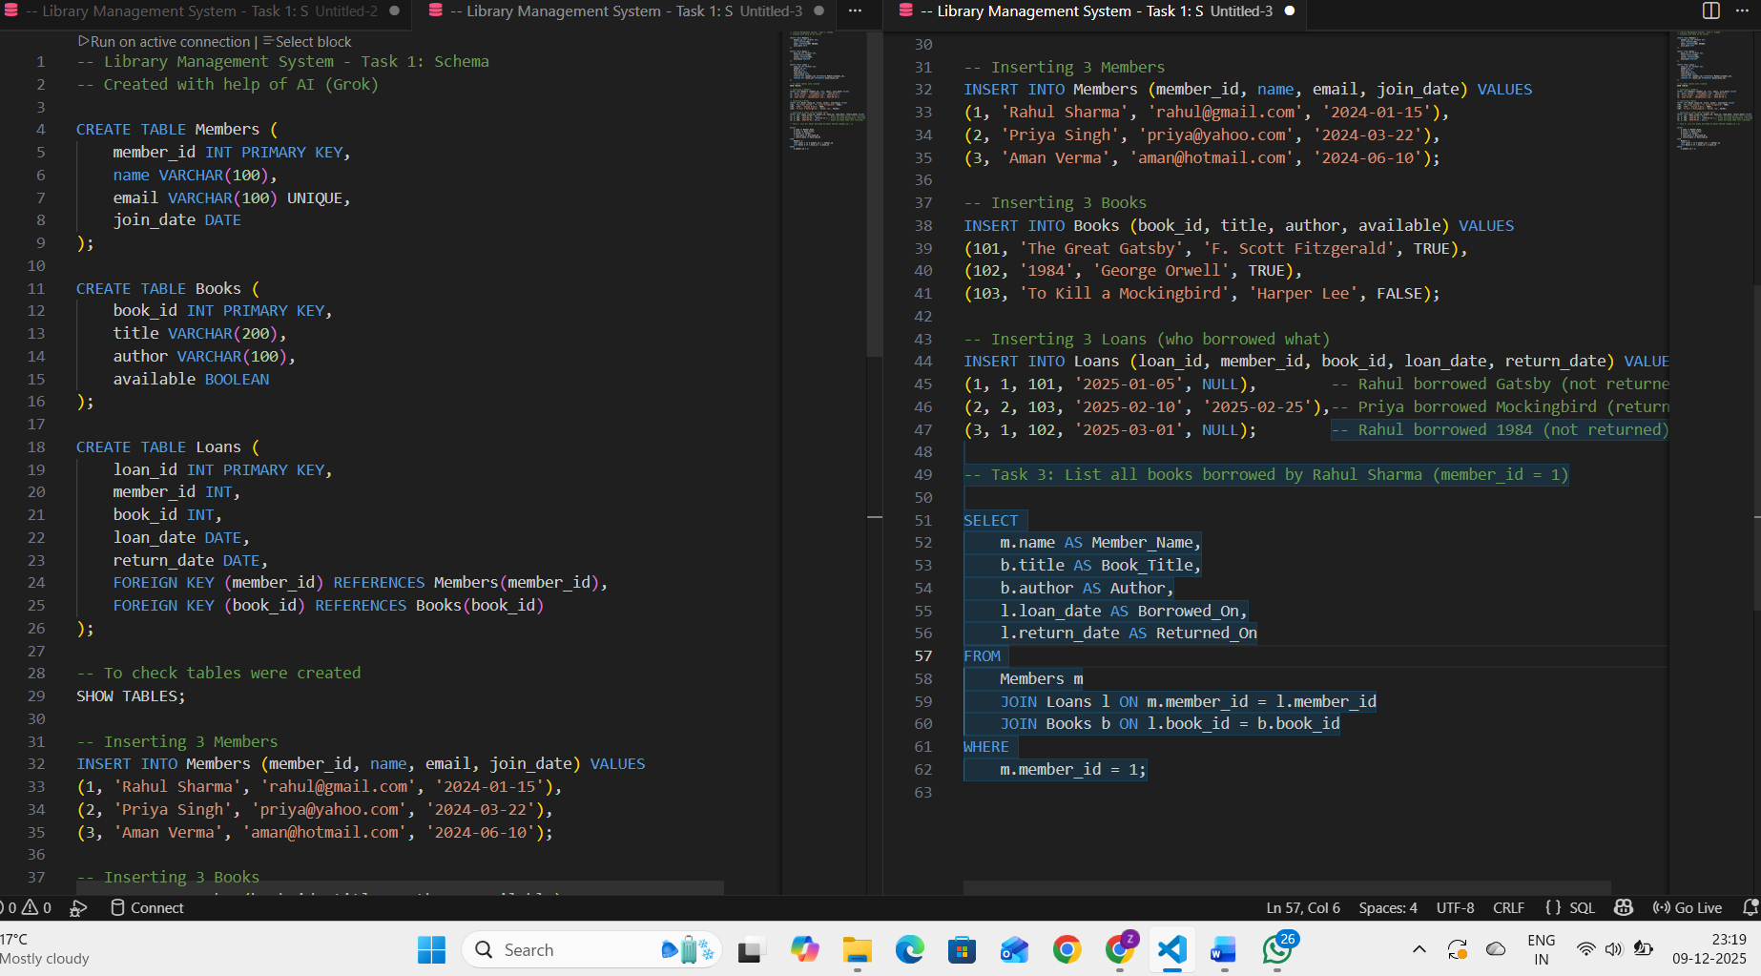  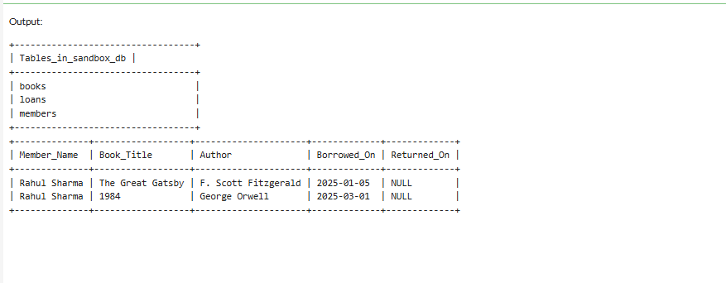  Basic Queries (Completed)  What we have done:  - Used AI to generate a single SQL query to list all books borrowed by a specific member.  - Combined data from Members, Loans, and Books tables using proper JOINs.  - Filtered results for member_id = 1 (Rahul Sharma).  - Displayed clear and readable columns: Member Name, Book Title, Author, Borrowed Date, and Returned Date.  - Successfully executed the query on OneCompiler MySQL.  - Correct output showed Rahul Sharma has borrowed two books: “The Great Gatsby” and “1984” (both not returned yet – NULL).  - Took screenshot of the query and its correct result as proof.  - Saved the query in VS Code file for submission and future use.  Result: Query perfectly shows all books borrowed by the selected member in a clean, easy-to-read format  Task Description #4 – Update and Delete Queries  Task: Generate queries with AI for:  - Updating a book’s availability to FALSE when borrowed.  - Deleting a member record safely.  Prompt : Update and Delete Queries Prompt given to AI: “Generate two safe queries:  - UPDATE query to change a book’s availability to FALSE when it is borrowed (for book_id = 101).  - Safe DELETE queries to completely remove a member (member_id = 3) who has no loans, without causing foreign key errors.”  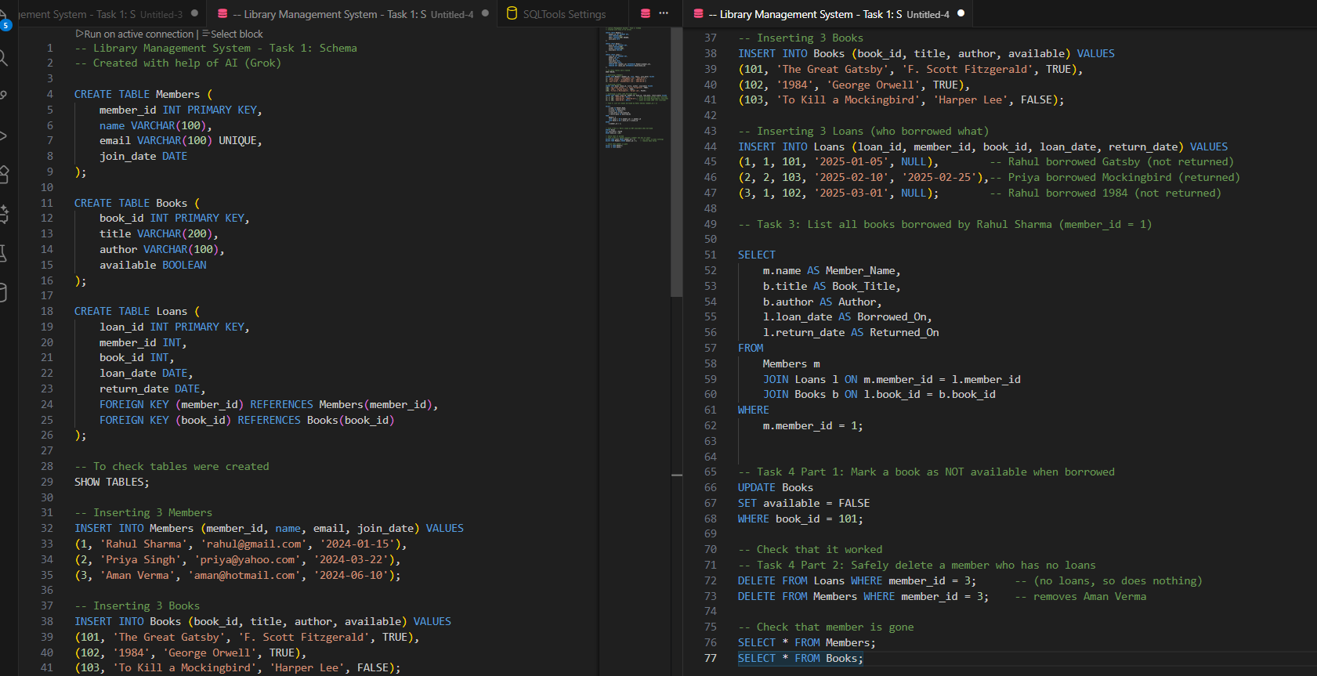  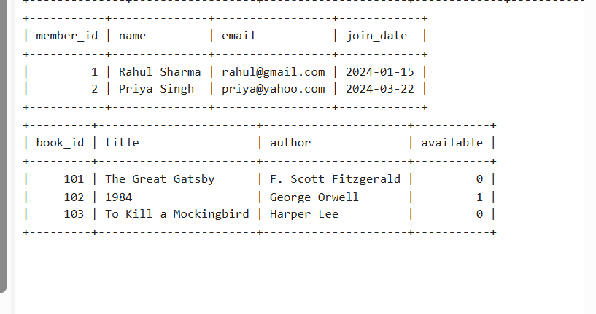  Used AI to create two types of queries: one to UPDATE (change) data in the database, and one to DELETE (remove) data. Specifically:  - UPDATE: Change a book’s "available" status to FALSE when someone borrows it (so no one else can borrow it).  - DELETE: Safely remove a member’s record from the database without causing errors (like if they have loans, we have to handle that first to avoid breaking the links).  This task teaches how to modify or remove data safely, which is important in real databases to keep everything consistent.  What We Have Done Step by Step (Detailed): We built on Tasks 1-3 (where we created tables, added sample data, and queried it). We added the new queries at the bottom of your existing code in OneCompiler MySQL. Here's exactly what happened:  - Prepared the Database (No Changes Needed): We used the same setup from Task 2 (3 members, 3 books, 3 loans). No errors because the tables and data were already there.  - Created and Ran the UPDATE Query:  - We focused on book_id = 101 (The Great Gatsby). It was originally available = TRUE (or 1, which means "yes, free to borrow").  - The query changed it to FALSE (or 0, meaning "not available, borrowed").  - We ran it, and it worked without error because it's a simple change to one field.  - To check, we showed the Books table – you saw available = 0 for book_id 101.  - Created and Ran the DELETE Query (Safely):  - We chose member_id = 3 (Aman Verma) because he had no loans (safe choice – no links to delete).  - First, we deleted any possible loans for him (this did nothing since he had none, but it's a safe habit to avoid "foreign key error" if there were loans).  - Then, we deleted the member himself.  - We ran it, and it worked without error because there were no active loans.  - To check, we showed the Members table – only 2 members left (Rahul and Priya).  - Verified Everything (Proof):  - After UPDATE: Books table showed the change (available = 0).  - After DELETE: Members table had only 2 rows.  - No errors like "cannot delete because of foreign key" – everything stayed consistent.

